

**FPT ACADEMY INTERNATIONAL**

**FPT – APTECH COMPUTER EDUCATION**

**DOMAIN**

*RYAN-Sports-Club*

Development Guide

|  |  |  |  |
| --- | --- | --- | --- |
| **Center Name** | | FPT – Aptech – HCM2  Address: 590 Cach Mang Thang Tam, District 3, Ho Chi Minh City | |
| **Instructor** | | Mr. Ngo Phuoc Nguyen | |
| **Class** | | T1.2009.A0 | |
| **Group** | | 4 | |
| **Group members** | | **Name** | **Student ID** |
| Pham Minh Tuan | Student1279065 |
| Nguyen Viet Tuan | Student1278911 |
| Le Quoc Thanh | Student1279561 |
|  | |  |  |
| **Duration** | **Start date** | 30 Nov 2020 | |
| **End date** | 30 Dec 2020 | |

**This is to certify that**

**Mr.:**

Pham Minh Tuan

Nguyen Viet Tuan

Le Quoc Thanh

**has successfully designed & developed**

eProject: RYAN-Sports-Club Website

**Submitted by:**

Pham Minh Tuan

**Date of issue:** 18 Dec 2020

**Authorized Signature:**

TABLE OF CONTENTS

Acknowledgement 3

Hardware/ Software Requirements 4

Architecture and design of the system 5

Diagram of the website 6

SITE MAP 8

Mock of the website 9

WEBSITE DESCRIPTION 11

1. Home page 11

2. About 11

3. Specialized 12

4. Sports 12

5. Team 13

6. Contact 13

JAVASCRIP,JQUERY DESCRIPTION 14,15

task sheet review 3 15

# 

# Acknowledgement

We think eproject is a very new way of learning for students. It helps students have more practical experience and more learning. Eproject helps students develop more skills than just IT knowledge. We think this is the fastest way to be successful in the future.

In the process we encountered a lot of problems and errors but eproject is a team work so it is a great motivation for us to try and pass and not give up. Especially eproject is one of the great ways we can learn and access complex, complex tasks in the future.

Eproject helps us revise all the learned knowledge in a real way and make a great connection to our team members and trainers.

Finally, thanks to Aptech’s eProject assignment, we had a golden opportunity to apply what we have learnt into reality and gain hands-on experience which is essential for our future career. And thanks to my Instructor Mr. Ngo Phuoc Nguyen again, he had helped us so much.

**Hardware/ Software Requirements**

* **For webmaster**

**Hardware**

* Intel Pentium 4 processor or higher
* 1 Gigabytes of RAM or higher

**Software**

* Windows 7 OS or higher
* Visual Studio Code and Sublime Text Code
* HTML5 and Javascript supporting web browsers such as IE, Chrome or Firefox
* **For web users**

**Hardware**

* Intel Pentium 4 processor or higher
* 512 Megabytes of RAM or higher

**Software**

* Windows XP OS or higher or Mac OS
* HTML5 and Javascript supporting web browsers such as IE, Chrome or Firefox

# Architecture and design of the system

**WEB SERVER (or Local Sever)**

Webpage request

**WEB BROWSER**

Requested Page

**RENDERING ENGINE**

INTERPRETATION

INTERPRETATION

# 

# 

# Diagram of the website

**Home**

**About**

**Specialized**

**Sports**

**Team**

**Contact**

**TASK SHEET REVIEW 1**

|  |  |  |  |  |  |  |  |
| --- | --- | --- | --- | --- | --- | --- | --- |
| **Project Ref. No.:**  **eP/Advertisement** **Portal Management** **System/01** | | **Project Title:** | **Activity Plan** **Prepared** **By:** | **Date of Preparation of Activity Plan:** | | | |
| **Sr.No.** | **Task** | **Actual Start** **Date** | **Actual** **Days** | **Team** **Mate** **Names** | **Status** |
| 1 | Problem Statement | Ryan-Sports-Club | TUAN | 10/12/20 | 1 | TUAN | Completed |
| 2 | Analysis of requirements about the website | 10/12/20 | 1 | TUAN | Completed |
| 3 | The scope of the work | 10/12/20 | 1 | TUAN | Completed |
| 4 | Architecture and design of the system | 10/12/20 | 1 | TUAN | Completed |
| 5 | Diagram of the website | 10/12/20 | 1 | TUAN | Completed |
| 6 | Task Sheet | 10/12/20 | 1 | TUAN | Completed |

|  |  |
| --- | --- |
| **Date:** | |
| Signature of Instructor:  **Mr. Ngo Phuoc Nguyen** | Signature of Team Leader:  **Pham Minh Tuan** |

# SITE MAP

**Homepage**

**Indoor And Outdoor Activities**

**Introduce About The Company**

**About**

**Contact**

**Contact Form**

**Our Location**

**Specialized**

**Website**

**Special Activities**

**Indoor Sports**

**Outdoor Sports**

**Water Sports**

**Sports**

**Information Developer Members**

**Team**

# Mock of the website

# (Our Website Is One Page)

|  |
| --- |
| **INDOOR SPORTS, OUTDOOR SPORTS ,**  **WATER SPORTS**  **INFORMATION DEVELOP MEMBERS** SPECIAL ACTIVITIES **INTRODUCE ABOUT THE COMPANY**  **RYAN-SPORTS-CLUB**  **(Homepage)**  **FOOTER**  **CONTACT FORM**  **OUR LOCATION** |

**TASK SHEET REVIEW 2**

|  |  |  |  |  |  |  |  |
| --- | --- | --- | --- | --- | --- | --- | --- |
| **Project Ref. No.:**  **eP/Advertisement** **Portal Management** **System/01** | | **Project Title:** | **Activity Plan** **Prepared** **By:** | **Date of Preparation of Activity Plan:** | | | |
| **Sr.No.** | **Task** | **Actual Start** **Date** | **Actual** **Days** | **Team** **Mate** **Names** | **Status** |
| 1 | Site map | Ryan-Sports-Club | MINH TUAN | 15/12/20 | 1 | MINH TUAN | Completed |
| 2 | Mock of the website | 15/12/20 | 1 | MINH TUAN | Completed |
| 3 | Task sheet | 15/12/20 | 1 | VIET TUAN | Completed |

|  |  |
| --- | --- |
| **Date:** | |
| Signature of Instructor:  **Mr. Ngo Phuoc Nguyen** | Signature of Team Leader:  **Pham Minh Tuan** |

# 

# WEBSITE DESCRIPTION

## Home page

1. *Description*

*Some pictures, videos describing some activities for you to visualize and a list of options...*

1. *Snapshot:*

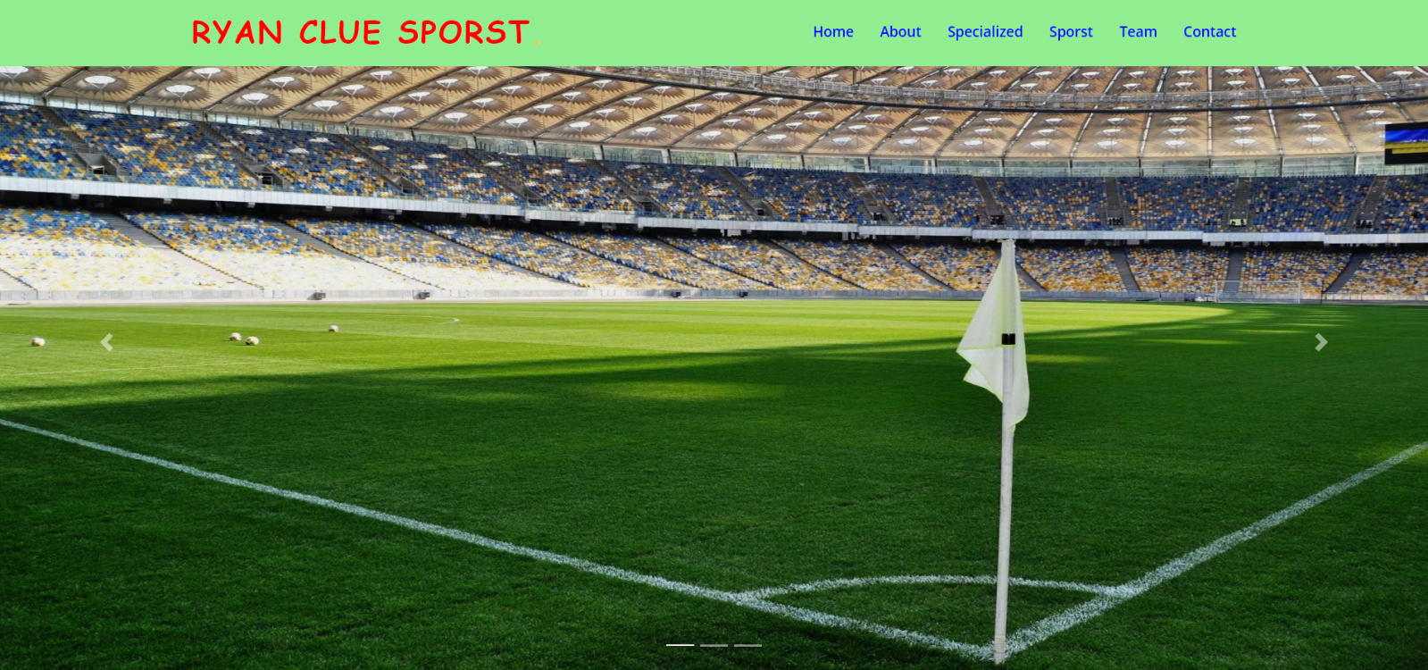

## About

1. *Description*

*A brief introduction to the model we are working on, the founding process, the challenges and opportunities…*

1. *Snapshot*

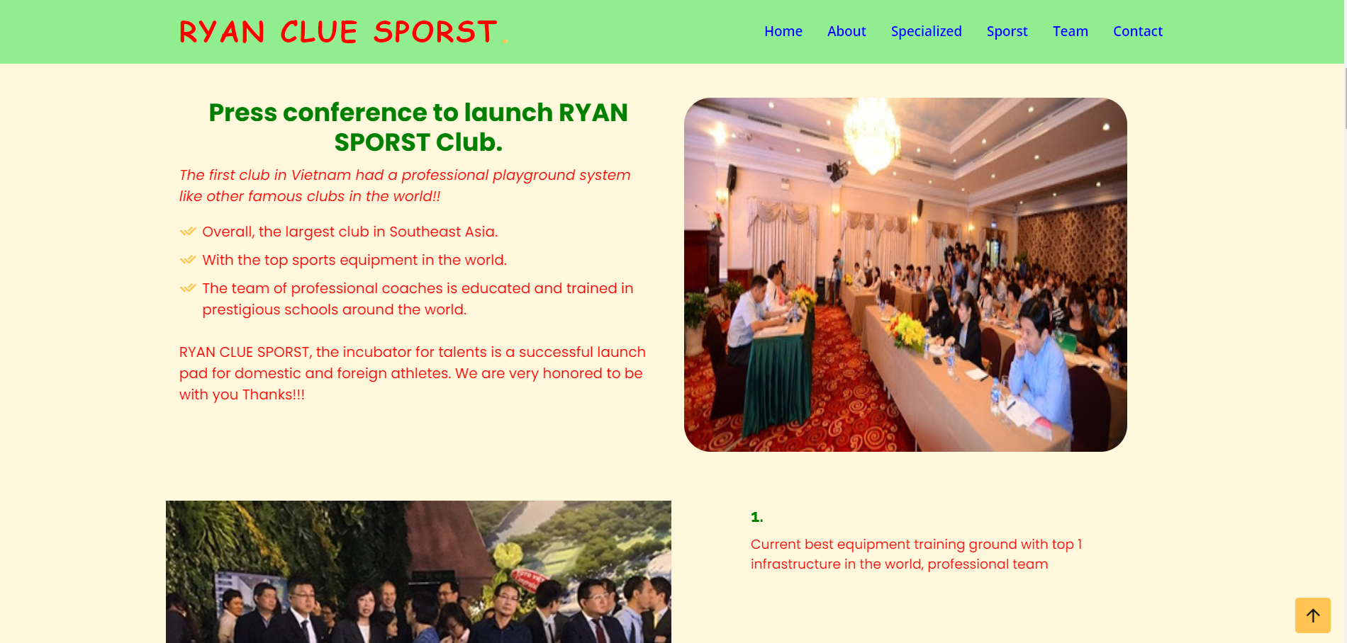

## 3. Specialized

1. *Description*

*Special events or major tournaments have been successful thanks to our model of action…*

1. *Snapshot*

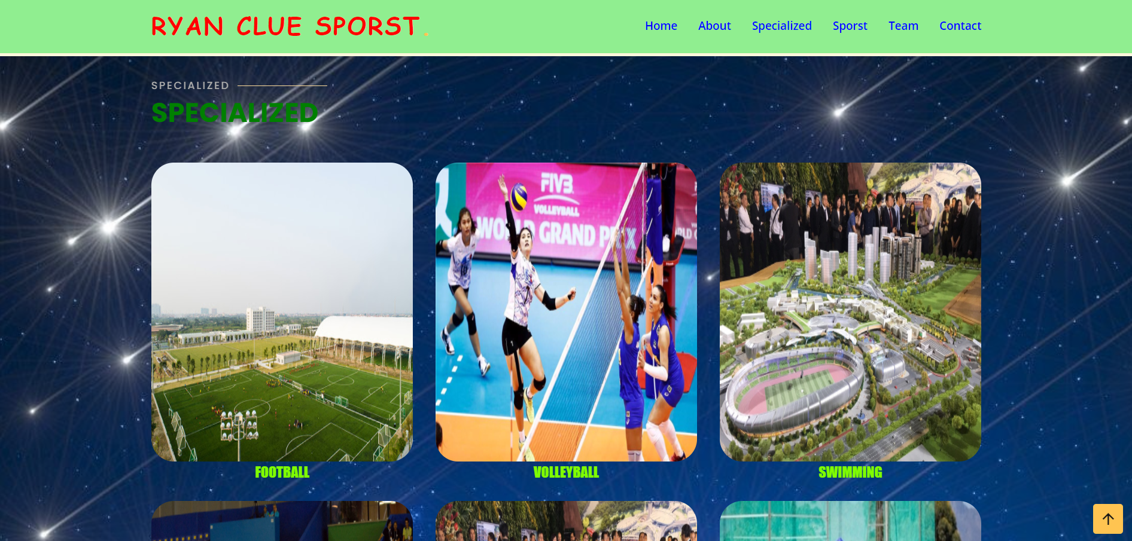

## Sports

1. *Description*

*Categorize sports or group activities for easy searching…*

1. *Snapshot*

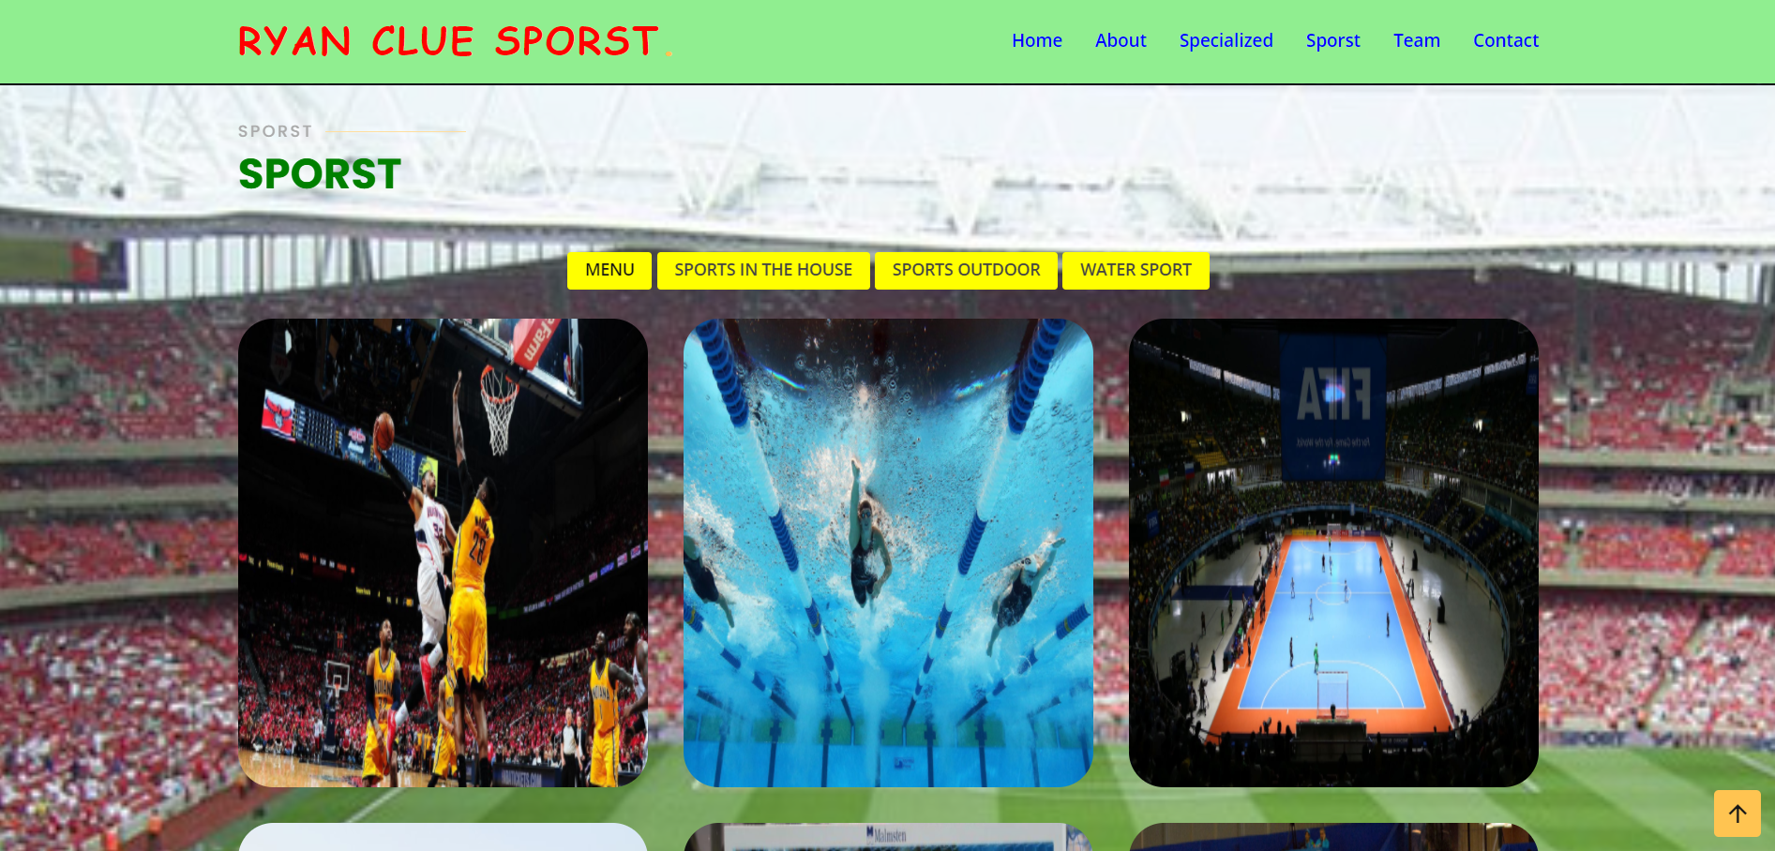

## Team

1. *Description*

*Contact us via apps that lead to your profile if something goes wrong or you want to provide suggestions to improve the site…*

1. *Snapshot*

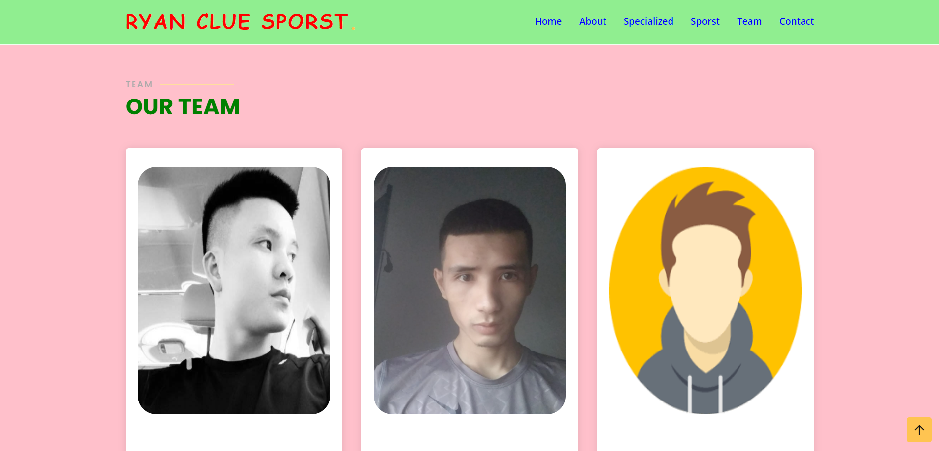

## Contact

1. *Description*

*Contact form help people connect with by normal way if they found wrong or error on our website or they want to help us with new idea or anything else…*

1. *Snapshot*

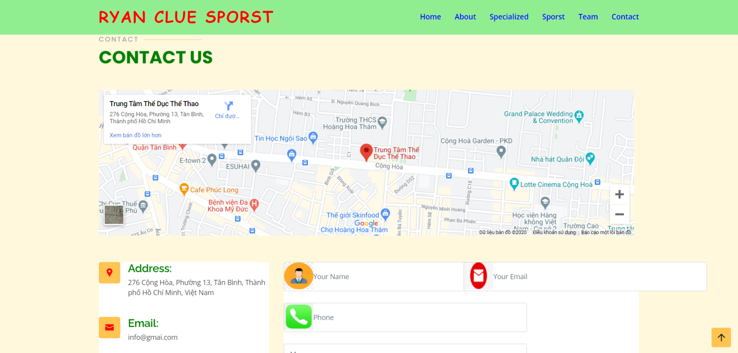

# JAVASCRIPT DESCRIPTION

## Carousel

1. *Description*

*We just use carousel for slide function. Automatically switch to another image in the slide show.*

1. *Snapshot:*

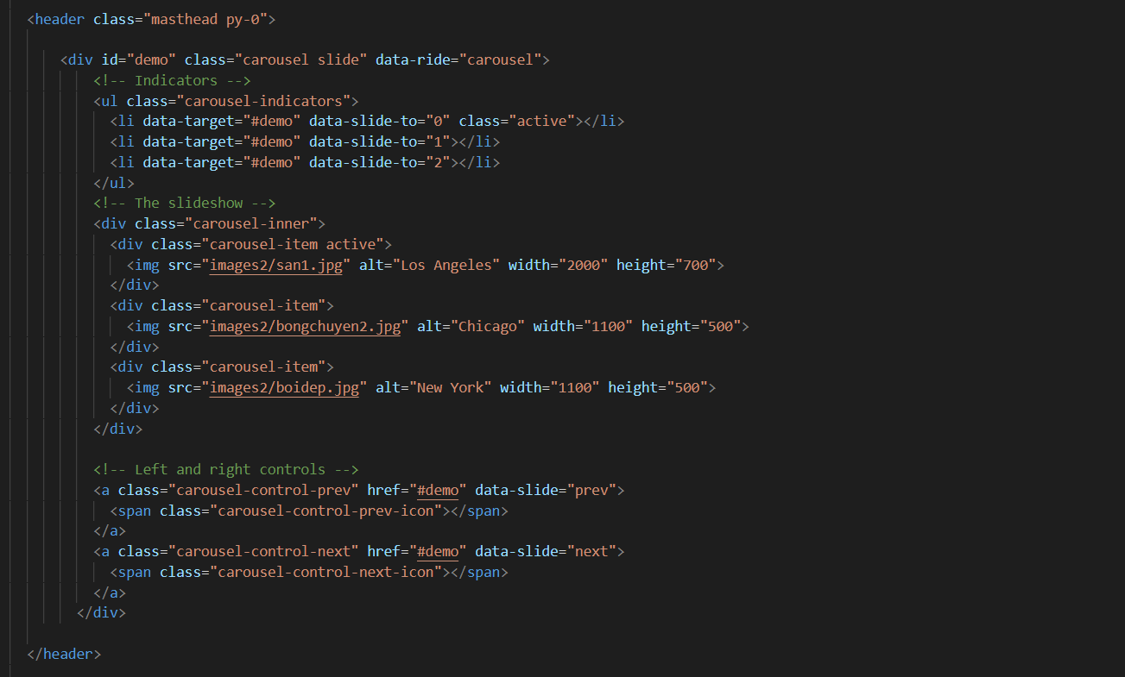

## HTML for Js

1. *Description*

*Use some jQuery snippets to easily find the sport you're interested in.*

1. *Snapshot:*

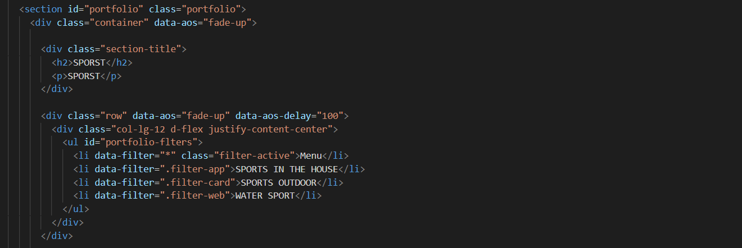

## Back to top animation

1. *Description*

*Smoother home page effect with jQuery.* *Can change the sliding effect and speed according to your needs.*

1. *Snapshot:*

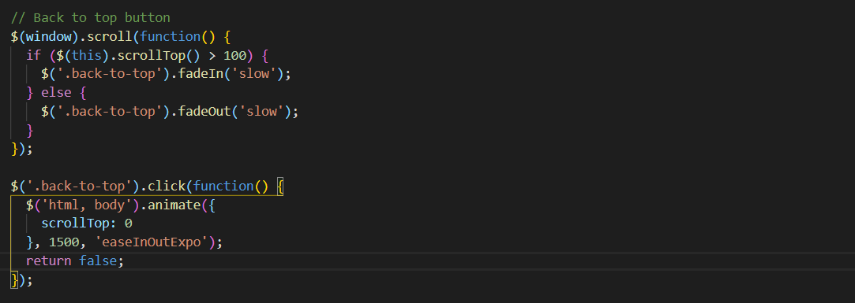

**TASK SHEET REVIEW 3**

|  |  |  |  |  |  |  |  |
| --- | --- | --- | --- | --- | --- | --- | --- |
| **Project Ref. No:**  **eP/Advertisement Portal Managament System/01** | | **Project Title:** | **Activity Plan Prepared by:** | **Date of Preparation of activity plan** | | | |
| **Sr. No.** | **Task** | **Actual start date** | **Actual days** | **Teammate name** | **Status** |
| 1 | Home | Ryan-Sports-Club | MINH TUAN | 30/12/2020 |  | MINH TUAN | Completed |
| 2 | About | 30/12/2020 |  | MINH TUAN | Completed |
| 3 | Specialized | 30/12/2020 |  | VIET TUAN | Completed |
| 4 | Sport | 30/12/2020 |  | VIET TUAN | Completed |
| 5 | Team | 30/12/2020 |  | THANH | Completed |
| 6 | Contact | 30/12/2020 |  | VIET TUAN | Completed |